**PPWC**

**Code1: Drawing a shape**

#include<stdio.h>

int main()

{

printf(" /|\n");

printf(" / |\n");

printf(" / |\n");

printf("/___|\n");

return 0;

}

Output:

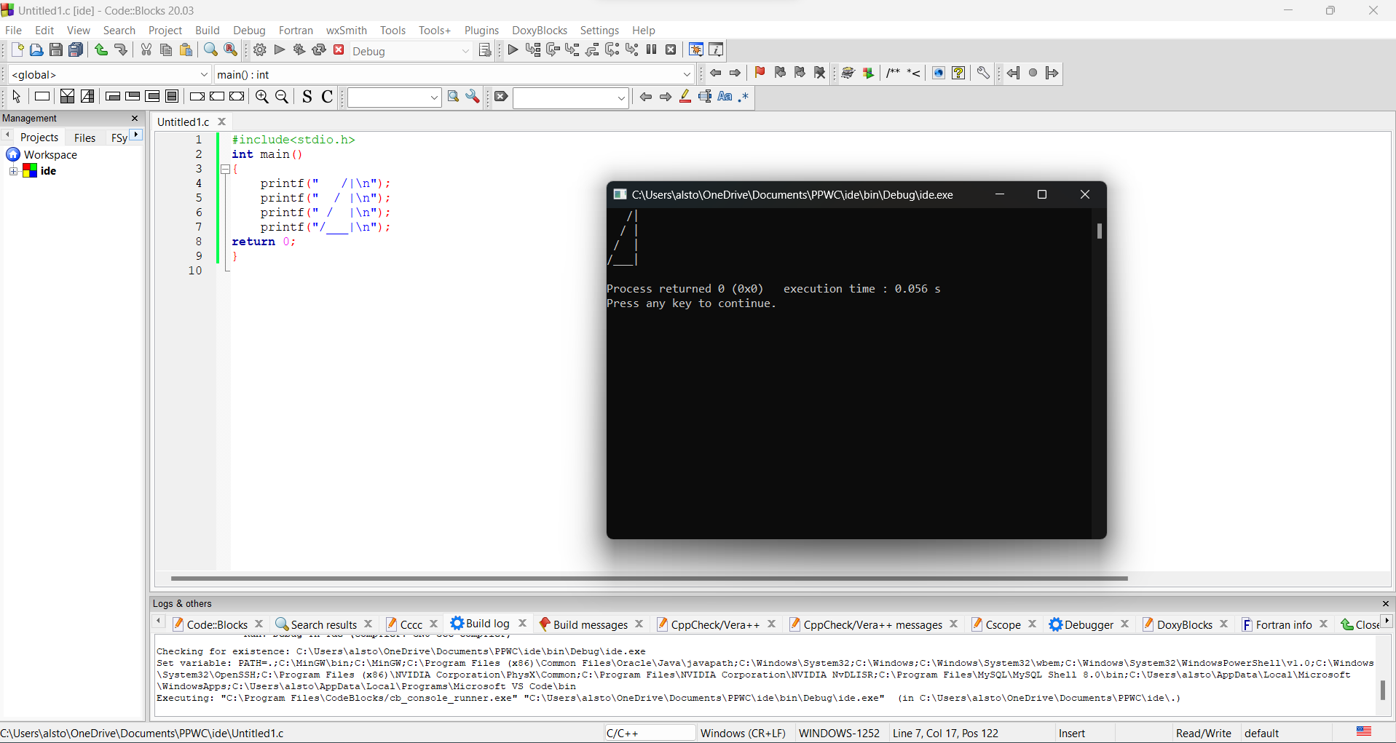

**Code2: Variables**

#include<stdio.h>

#include<stdib.h>

int main()

{

char characterName[] = "John";

int characterAge = 35;

printf("There once was a man named %s\n", characterName);

printf("He was %d years old.\n", characterAge );

printf("He really liked the name %s\n", characterName);

printf("but did not like being %d.\n", characterAge);

return 0;

}

Output:

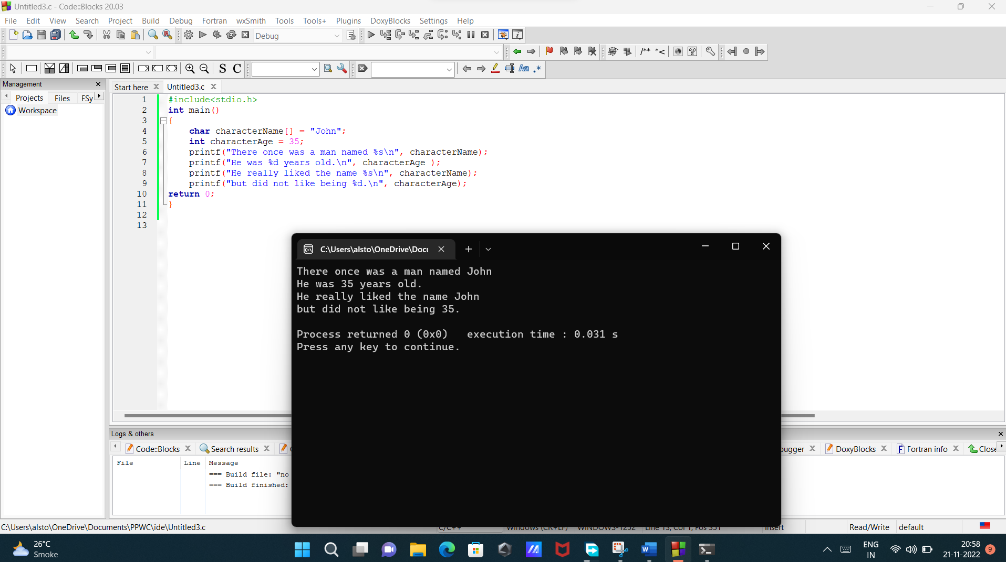

**Code3:working with numbers.**

#include<stdio.h>

#include<stdlib.h>

int main()

{

printf("%f",5 * 4.5);

return 0;

}

Output:

